WorkZone - Freelance Marketplace Platform

Submitted By:
Sarim Ayubi (2312132)
Muhammad Al-faid (2312119)
Course: Database System (DBS)
Instructor: Sir Abid Ali
Submission Date: 11-06-2025

Table of Contents
1. Introduction
2. Project Objective
3. Tools and Technologies
4. System Architecture
5. Database Design
6. Features Overview
7. Individual Pages Description
8. Code Example (Chart.js)
9. Screenshots
10. Conclusion
11. Future Scope
12. References

Introduction
WorkZone is a basic freelance marketplace platform designed to help freelancers and clients interact with each other...

Project Objective
The main goal of this project is to display and post data using self-created APIs...

Tools and Technologies
HTML5 & CSS3
- Bootstrap 5.3.2
- JavaScript
- Node.js
- Express.js
- PostgreSQL (Neon.tech)
- Chart.js
- GitHub
- draw.io

System Architecture
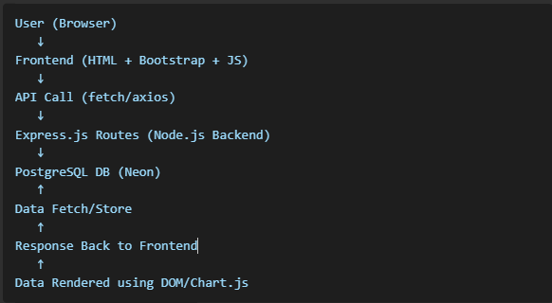
Database Design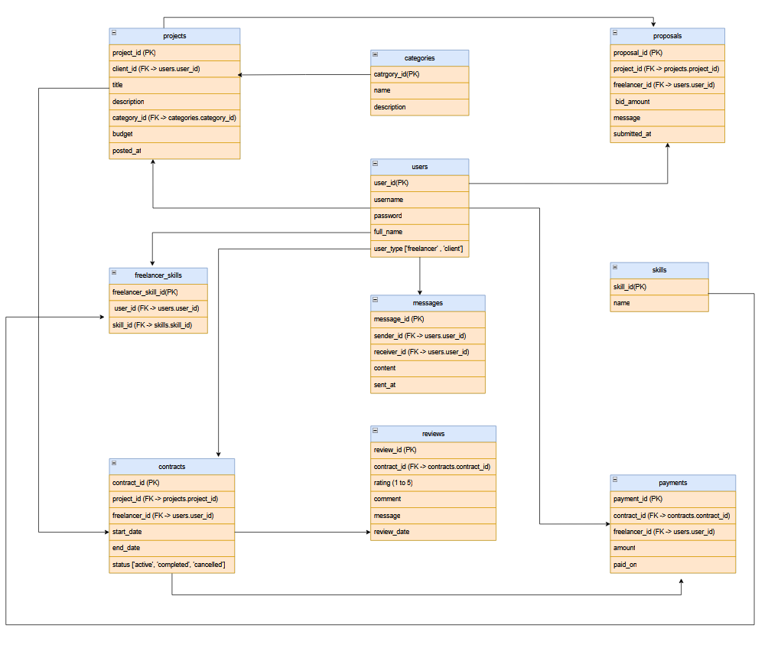

Features Overview
-Responsive design
- API-based data handling
- Chart visualization
- Form insertion

Individual Pages Description
index.html: HOME PAGE
<div class="row row-cols-2 row-cols-md-5 g-4 justify-content-center">
<div class="col"><a href="users.html" class="table-card d-block">Users</a></div>
<div class="col"><a href="categories.html" class="table-card d-block">Categories</a></div>
<div class="col"><a href="skills.html" class="table-card d-block">Skills</a></div>
<div class="col"><a href="freelancer_skills.html" class="table-card d-block">Freelancer Skills</a></div>
<div class="col"><a href="projects.html" class="table-card d-block">Projects</a></div>
<div class="col"><a href="proposals.html" class="table-card d-block">Proposals</a></div>
<div class="col"><a href="contracts.html" class="table-card d-block">Contracts</a></div>
<div class="col"><a href="reviews.html" class="table-card d-block">Reviews</a></div>
<div class="col"><a href="payments.html" class="table-card d-block">Payments</a></div>
<div class="col"><a href="messages.html" class="table-card d-block">Messages</a></div>
</div>
users.html: users table and chart
<div class="table-responsive shadow-sm rounded" id="tableSection">
<table class="table table-bordered mb-0" id="usersTable">
<thead class="table-secondary">
<tr class="text-center">
<th>USER ID</th>
<th>USERNAME</th>
<th>EMAIL</th>
<th>PASSWORD</th>
<th>FULL NAME</th>
<th>USER TYPE</th>
<th>CREATED AT</th>
</tr>
</thead>
<tbody></tbody>
</table>
</div>

Code Example (Chart.js)
HTML TAG FOR CHART:
<canvas id="userChart" width="400" height="400"></canvas>
CHART.JS CODE:
chartInstance = new Chart(ctx, {
type: "pie",
data: {
labels,
datasets: [{
label: "User Count",
data,
backgroundColor:["skyblue", "lightpink"],
borderRadius: 5,

borderColor: "white",
borderWidth: 1
}]
},
options: {
responsive: true,
plugins: {
legend: {
position: 'bottom' }}}});}

Screenshots
HOME PAGE (index.html)
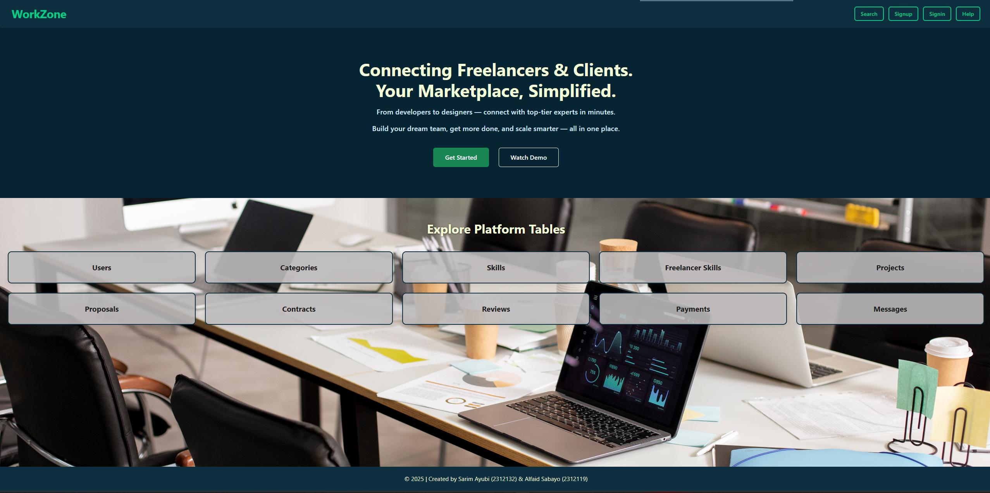
(user.html)
USER TABLE
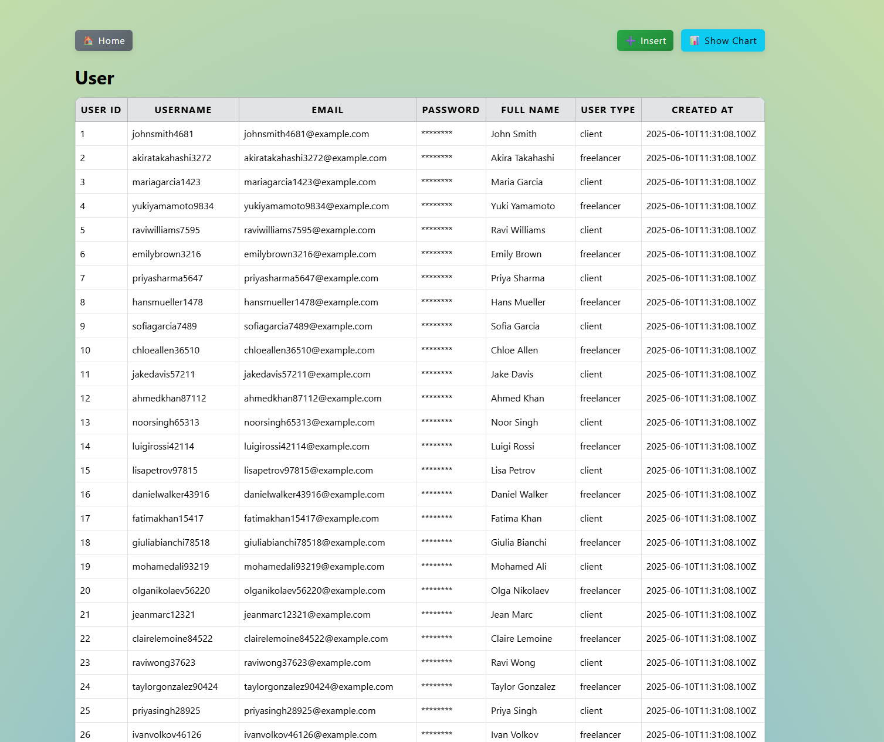
USER FORM TO INSERT NEW DATA
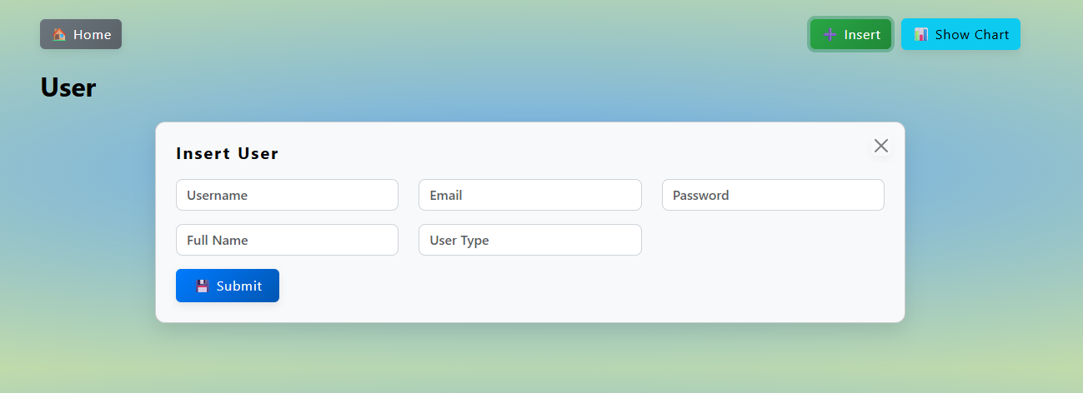
USER CHART
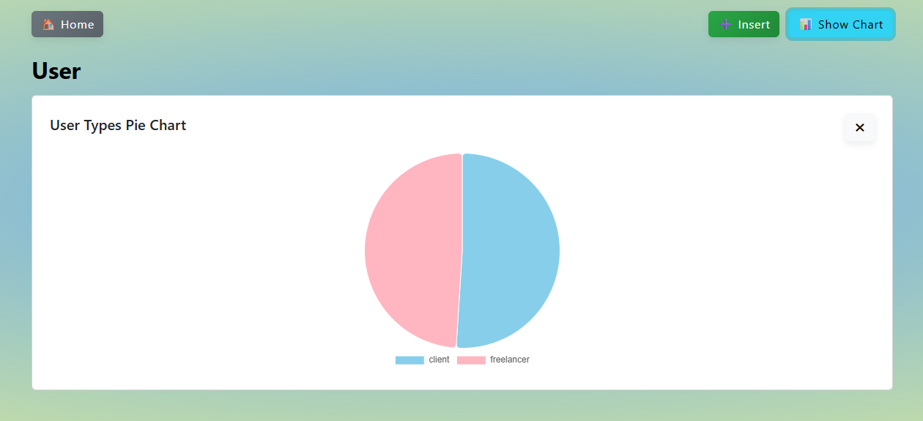

Conclusion
Helped us learn frontend-backend interaction and data visualization.

Future Scope
- Add login/auth
- Admin panel
- CRUD features

References
- Bootstrap Docs
- Chart.js Docs
- W3Schools
- Draw.io

